DIA Survey: preliminary results
04/10/21

Number of respondents: 30

Question 1
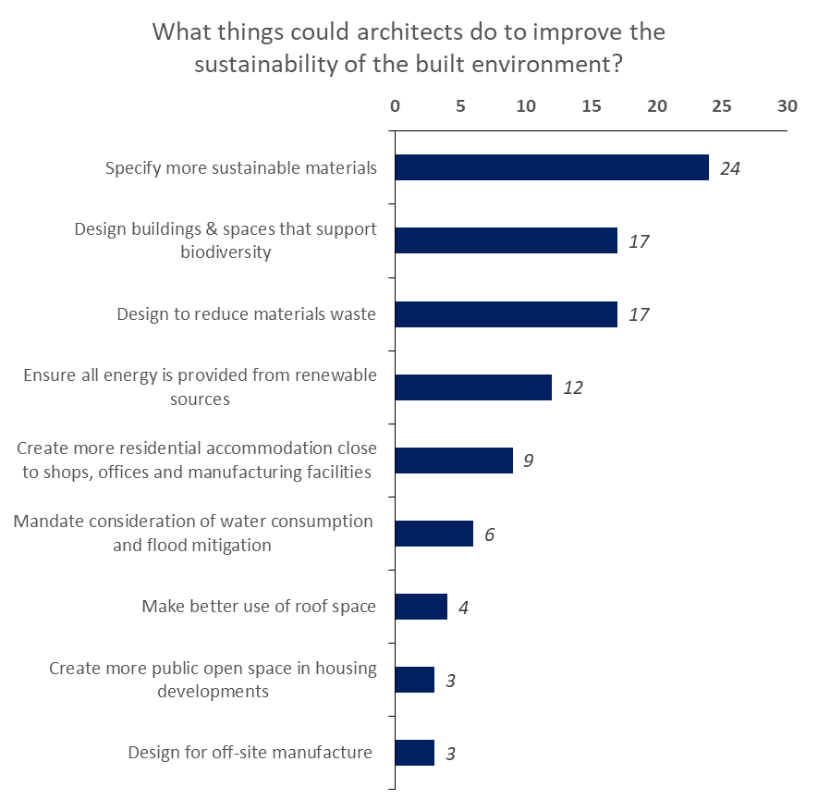
Other Suggestions:
- Make "sustainability" synonymous with "design" to ensure all the points above are the way architects work on all projects.
- Design building which can be adapted for different use in 10/15 years, reducing the toxic build/demolish cycle.
- Re-use buildings, part of buildings, sites wherever safe to do so.
- Lobby parliament to increase insulation standards
- Work with specialist energy consultants to improve every project from the design stage
- Avoid ecotoxic materials

Question 2
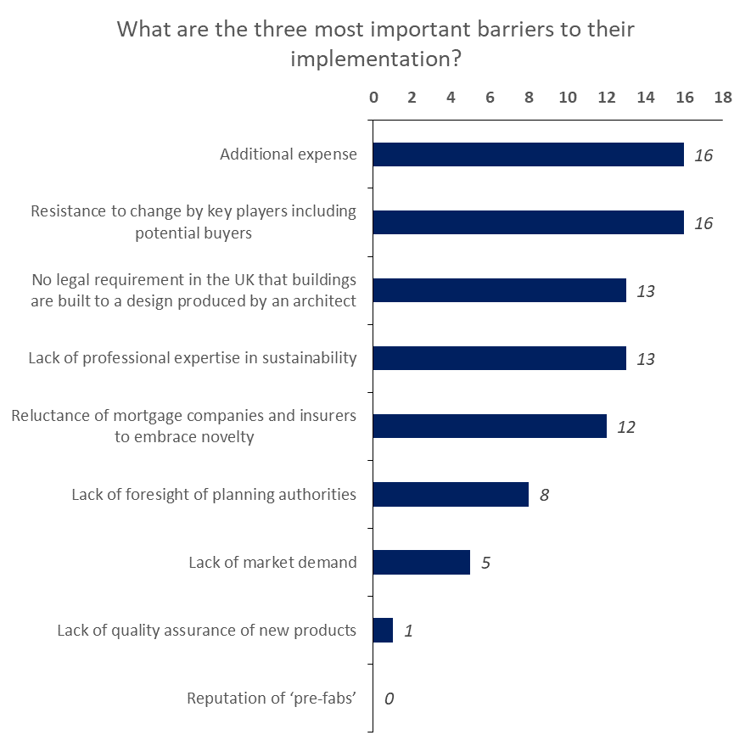
Other Suggestions:
- No legal requirement to carry out building performance verification/ post occupancy evaluation
- Lack of expertise among educators in sustainable design
- PIR and PUR insulations, and cement based products are "standard"

Question 3
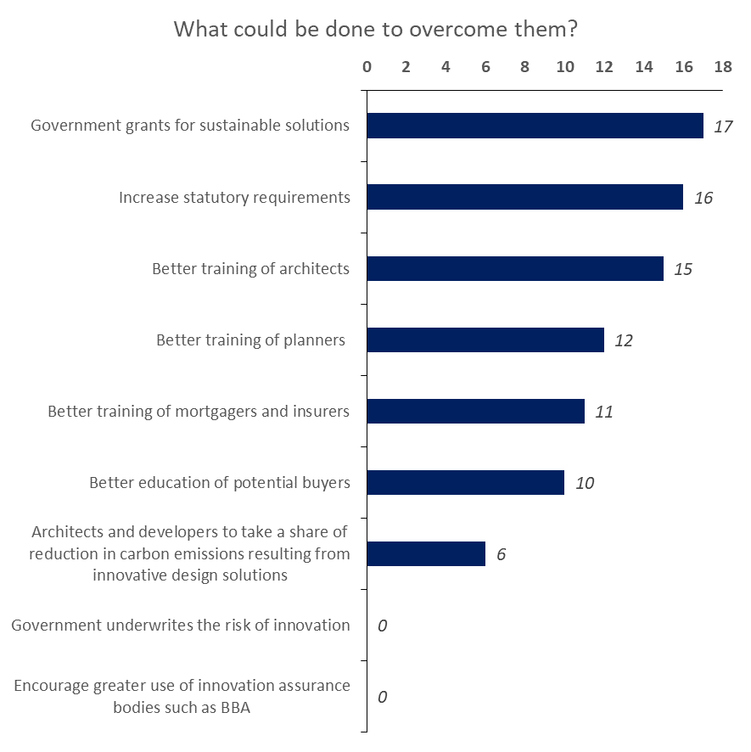
Other Suggestions:
- Demand that speculative housing focuses on sustainability not energy efficiency (which can be incredibly bad for the environment when done with the wrong materials or in the wrong place.
- Exert political pressure on the Ministry of Local Housing and the Ministry of the Environment
- introduce mandatory requirement for architects to carry out building performance evaluation of their design work - to check if there is a real building performance gap or not. There usually is.

